Claude Certification — Building with the Claude API
Section 7 — Features of Claude
Contents
- Lesson 1 — Extended Thinking
- Lesson 2 — Image Support

Lesson 1 — Extended Thinking

Core idea
Extended thinking is Claude's advanced reasoning feature: it gives the model time to work through a complex problem before writing the final answer. Think of it as Claude's “scratch paper” — you can see the reasoning process that leads to the answer, which helps with transparency and often improves response quality.

How It Works
With thinking enabled, the assistant message changes from a single text block into a structured response with two parts: a thinking block (the reasoning process) and a text block (the final answer). The diagram below shows the same recursion example: the user message is unchanged, but the assistant now returns a thinking block before the text block.
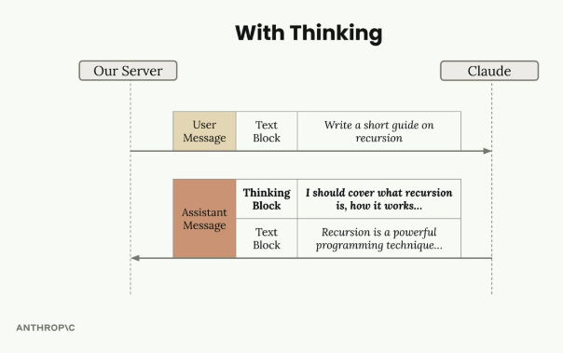
With extended thinking enabled, the assistant message contains a Thinking Block followed by the final Text Block.

Benefits
- Better reasoning — improved capability on complex tasks.
- Higher accuracy — on difficult problems where standard prompting falls short.
- Transparency — visibility into Claude's thought process.

Trade-offs
- Higher cost — thinking tokens are billed.
- Increased latency — thinking takes time before the final answer arrives.
- More complex response handling — code must handle the extra block type.

When to Use Extended Thinking
The decision is driven by evaluation results, not intuition: run prompts without thinking first, and if accuracy isn't meeting requirements after the prompt has already been optimized, then consider enabling extended thinking. It's a tool for when standard prompting isn't quite getting you there — not a default to switch on for every request.

The Signature: Response Security
Extended thinking responses include a signature field — a cryptographic token tied to the exact thinking text Claude generated. It verifies that the thinking content wasn't modified before being sent back to the API, preventing a developer from tampering with Claude's reasoning process in a way that could steer the model in unsafe directions.
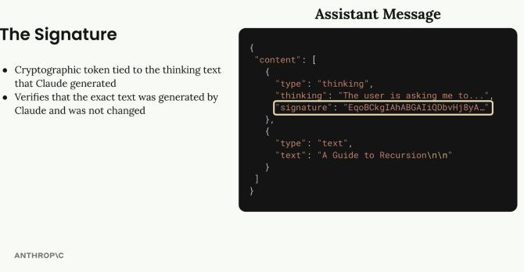
The signature field inside the thinking block is a cryptographic token tied to the exact reasoning text — it must be passed back unchanged.

Redacted Thinking
Sometimes, instead of readable reasoning text, the API returns a redacted_thinking block. This happens when Claude's internal reasoning gets flagged by safety systems. The block still contains the actual thinking, but encrypted, so the full message can be passed back to Claude in later turns without losing context. For testing, a special trigger string can be sent as the prompt to force a redacted thinking block, so an application's handling of this case can be verified without waiting for a real flag.

Implementation
Enabling extended thinking takes two new parameters on the chat function: a thinking flag and a thinking_budget (the max tokens Claude may use for reasoning, minimum 1024). The max_tokens parameter must be set higher than the thinking budget.
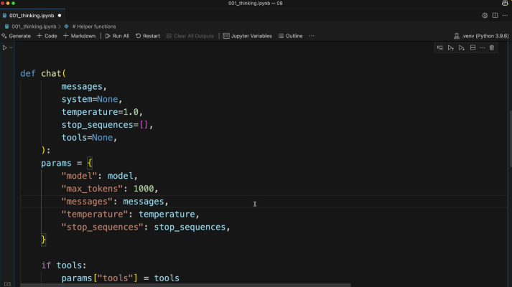
The chat() helper function that gets extended with thinking and thinking_budget parameters.
def chat(
messages,
system=None,
temperature=1.0,
stop_sequences=[],
tools=None,
thinking=False,
thinking_budget=1024
):
The thinking configuration is only added to the request parameters when thinking is turned on:
if thinking:
params["thinking"] = {
"type": "enabled",
"budget": thinking_budget
}
Calling it is then a matter of passing the flag:
chat(messages, thinking=True)

Practice Questions — Lesson 1
Choose the single best answer for each question (A–E).
1. What is extended thinking best described as?
A) A way to fine-tune Claude on custom data
B) A feature that gives Claude time to reason through a problem before the final answer, shown as a separate thinking block
C) A tool that lets Claude browse the web
D) A caching mechanism for repeated prompts
E) A way to reduce the number of tokens in a response
2. Which of the following is NOT listed as a benefit of extended thinking?
A) Better reasoning on complex tasks
B) Increased accuracy on difficult problems
C) Transparency into Claude's thought process
D) Lower latency on every request
E) Often results in higher quality responses
3. According to the lesson, when should a developer consider enabling extended thinking?
A) On every single API call, by default
B) Only for creative writing tasks
C) After running prompt evaluations without thinking and finding accuracy still isn't sufficient once the prompt is already optimized
D) Only when the user explicitly types "think" in the prompt
E) Never — it should be avoided in production
4. What does the signature field in a thinking block verify?
A) That the user's API key is valid
B) That the model used was Claude 4
C) That the thinking text is exactly what Claude generated and was not modified
D) That the response fits within max_tokens
E) That the thinking block was translated correctly
5. What triggers a redacted_thinking block instead of a normal thinking block?
A) The thinking_budget is set too low
B) The user asks a factual question
C) Claude's internal reasoning gets flagged by safety systems
D) The max_tokens parameter is missing
E) The request does not include any tools
6. In the redacted_thinking case, what happens to the underlying reasoning content?
A) It is permanently deleted and cannot be reused
B) It is kept in encrypted form so it can be passed back to Claude without losing context
C) It is shown to the developer but hidden from the end user
D) It is converted into a normal text block automatically
E) It is replaced with a generic placeholder message with no relation to the original reasoning

Lesson 2 — Image Support

Core idea
Claude's vision capabilities let you include images in messages and ask Claude to analyze them: describe what's in an image, compare multiple images, count objects, or perform more complex visual analysis.

Limits to Keep in Mind
- Up to 100 images across all messages in a single request.
- Max size of 5MB per image.
- Single image: max height/width of 8000px.
- Multiple images: max height/width of 2000px.
- Encoding — images can be sent as base64 or as a URL to the image.
- Token cost — each image counts as tokens = (width px × height px) / 750.

Sending an Image
An image block goes in the user message alongside a text block. The image is read from disk, base64-encoded, and passed with its media type; the text block carries the question about the image.
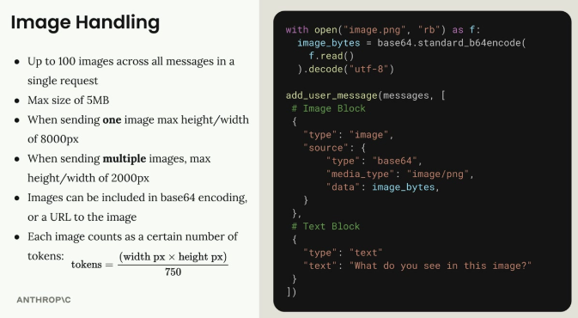
An image block (base64-encoded PNG) plus a text block, both inside the same user message.
with open("image.png", "rb") as f:
image_bytes = base64.standard_b64encode(
f.read()
).decode("utf-8")

add_user_message(messages, [
# Image Block
{
"type": "image",
"source": {
"type": "base64",
"media_type": "image/png",
"data": image_bytes,
}
},
# Text Block
{
"type": "text",
"text": "What do you see in this image?"
}
])

Message Flow
The conversation works just like text-only interactions: the server sends a user message with both an image block and a text block, and Claude responds with a text block containing its analysis.
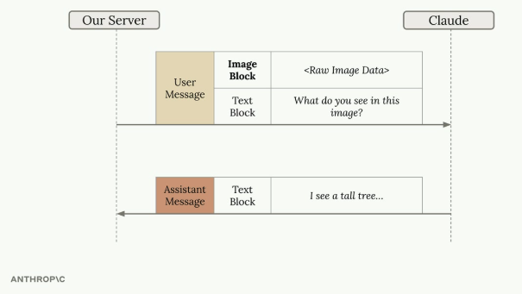
User message carries an Image Block plus a Text Block; Claude replies with a Text Block describing what it sees.

Prompting Techniques for Images
The same prompt engineering techniques that work for text apply to images. A simple question often leads to poor results — asking "How many marbles are in this image?" can return an incorrect count.
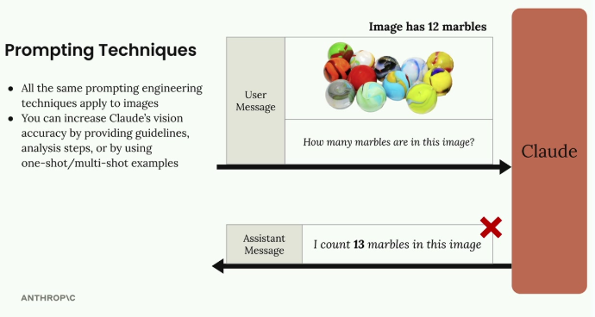
A simple question ("How many marbles?") on an image of 12 marbles returns the wrong count: 13.
Accuracy improves by providing detailed guidelines and analysis steps, using one-shot or multi-shot examples, and breaking complex tasks into smaller steps.

Step-by-Step Analysis
Instead of a simple question, give Claude a methodology to follow — identify and number each item one at a time, then verify with a second counting method (e.g. row by row from a fixed starting corner). Asking for the exact, verified number this way corrects the earlier miscount.
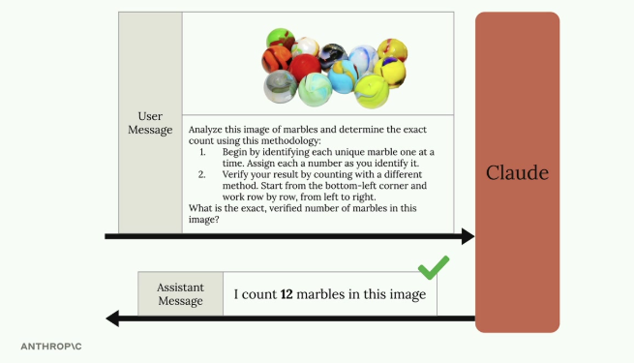
A structured, two-step counting methodology gets the correct count: 12 marbles.

One-Shot Examples
Accuracy can also improve by providing an example within the message: include a reference image with a known, stated count, then ask about the target image. This gives Claude a concrete reference point for the type of analysis expected before it answers the real question.
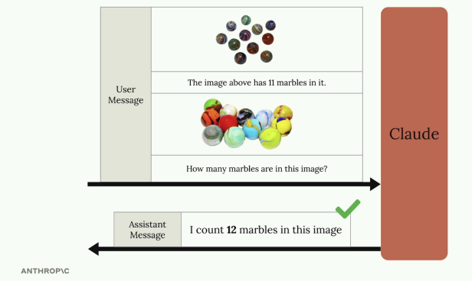
A reference image labeled with its known count (11 marbles) precedes the target image, helping Claude correctly count 12 marbles in the second image.

Real-World Example: Fire Risk Assessment
A practical application: automating fire risk assessments for home insurance. Instead of sending inspectors to every property, insurers can analyze high-resolution satellite imagery with Claude, identifying dense tree cover near the residence, difficult access for emergency services, and branches overhanging the structure.
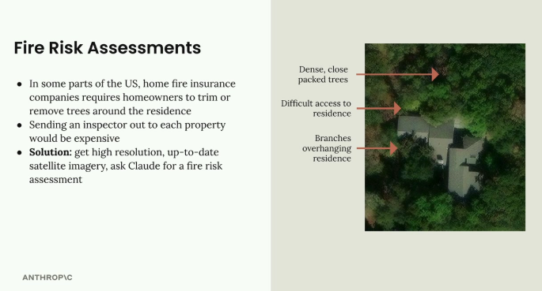
Satellite imagery annotated with fire-risk factors: dense packed trees, difficult residence access, and overhanging branches.
Rather than a vague prompt like "provide a fire risk score," a well-structured prompt breaks the analysis into explicit steps: locate the residence, analyze tree overhang and estimate the percentage of roof covered, assess wildfire vulnerability factors, evaluate the property's defensible space, and only then assign a Fire Risk Rating from 1 (Low) to 4 (Severe) — one summary sentence per step, with the numerical rating as the final answer. This systematic structure produces far more accurate and useful assessments than a simple request.

Practice Questions — Lesson 2
Choose the single best answer for each question (A–E).
1. What is the maximum number of images allowed across all messages in a single request?
A) 10
B) 20
C) 50
D) 100
E) There is no limit
2. When sending multiple images in a single request, what is the max height/width per image?
A) 2000px
B) 5000px
C) 8000px
D) 10000px
E) There is no size limit for multiple images
3. How is the token cost of an image calculated?
A) A flat 1000 tokens per image regardless of size
B) (width px × height px) / 750
C) (width px + height px) / 2
D) Based on file size in MB only
E) Images do not consume tokens
4. Why did the simple prompt "How many marbles are in this image?" return an incorrect count?
A) Because the image exceeded the 5MB size limit
B) Because Claude cannot process images with more than one color
C) Because a simple, unstructured prompt often leads to poor results on precise visual tasks
D) Because the image was sent as a URL instead of base64
E) Because counting tasks are not supported by the vision API
5. According to the lesson, which techniques improve Claude's accuracy on image analysis tasks?
A) Sending only the image with no text block at all
B) Detailed guidelines and analysis steps, one-shot/multi-shot examples, and breaking tasks into smaller steps
C) Always resizing images to exactly 8000px
D) Repeating the same question multiple times in the same message
E) Removing all context and asking the shortest possible question
6. In the fire risk assessment example, what is the final output of the structured prompt?
A) A raw list of every tree detected in the image
B) A one-sentence summary per analysis step, ending in a numerical Fire Risk Rating from 1 to 4
C) A base64-encoded copy of the satellite image
D) A yes/no answer on whether to send an inspector
E) The exact GPS coordinates of the residence

